TIS2151 Web Application Development

Assignment Submission Cover Grading Sheet: Assignment 2 (15%)

Due Date: 2nd Oct 2015 (Friday) before 5.00 p.m.

No | Student Name | Student ID | Final Score
1 | Muhammad Redza Bin Ruslan | 1102700453
2 | Muhammad Aiman Bin Kamal | 1102700205
3 | Ahmad Nazreen Bin Ahmad Kamarulzaman | 1102703236
4 | Imran Bin Ab Azmar | 1112702852

Your Homepage URL

Item Required By Instructor to Hand-in
☑Softcopy
Assignment Cover Page ◻
Source Code ◻
Sample Browser Output (Screenshots) ◻

** Include your group member name and ID in the title of all the files
** Save all the files in a CD instead in a diskette. Make sure the contents in the CD are readable.
** All solutions must be in computer-printed form. Solutions in hand-writing are not accepted.

Program Grading
(To Be Filled Out By The Instructor)

 | Grading Elements
Items | Total (3%) |  | Remarks
Online on Server
Homepage
Conference Materials
Registration Form
Query Form
Overall Score (15%)
Late Submission Penalty 2marks x ____ Day(s)
Final Score

Due Date: 2nd Oct 2015 (Friday) before 5.00 p.m.

Minimum number of member is 3 and maximum is 4.

Things to submit:
The softcopy should contains the following files in a zip file and emailed to fci.tis2151@gmail.com :
1] assignment submission cover with grading sheet
2] solutions for all question (source code and instruction, if any)

Important: Please make sure you use the following format as the subject of your email:
TIS2151 Assignment 2 [List of Student IDs]
Remarks:
** Include your group member name and ID in the footer of your HTML pages.

** Late submission: 2 marks per day
Important: copying is a serious offense, all act of cheating will be penalized.

For this assignment, you are required to develop an online website for an academic conference. You are free to choose the scope of the conference. Your website should contain a homepage that explain briefly the objectives of your conference and links to the following web pages:

Reservation Form
Create a reservation form that allows users to register for your conference. Users should provide their personal details such as their name, affiliation, contact number, and email address. Your HTML form should validate the input given by the users. If the form has been filled out correctly, then stores the information into a database.

Query Form
Write a PHP script that allows users to view the latest list of participants registered for this conference. Users may sort the list by participant name and affiliation.

Workshop Materials

This page should provide information on your conference agenda, venue, speakers, and company contact details. You may use anything we have learned in the course to create this web page.

Live version of this website can be found at: http://tis2151.github.io

- Home

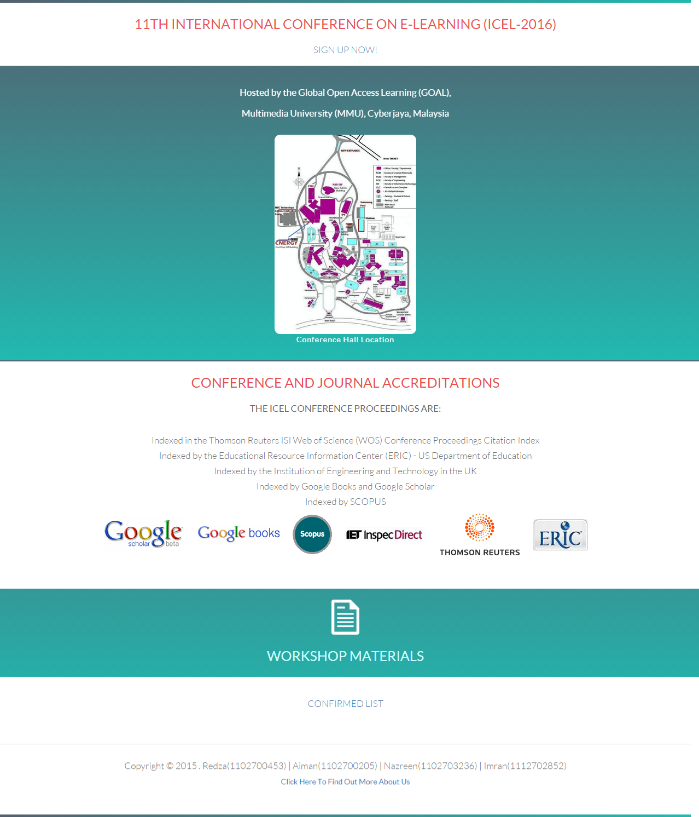
<!DOCTYPE html>
<html>
<head>
<title>TIS2151</title>
<link rel="icon" type="image/png" href="image/pagecon.png">
<meta charset=”utf-8”>
<meta name="viewport" content="width=device-width, initial-scale=1">
<link rel="stylesheet" href="css/bootstrap.css">
<link rel="stylesheet" href="css/style.css">
<link href="css/css" rel="stylesheet" type="text/css">
<link rel="stylesheet" href="css/animate.css">

</head>

<body>
<center>

<div class="parallax" style="padding: 0px 0 50px 0;">
<div class="topline"></div>

<div class="container"><a href="home2.html" style="text-decoration:none">
<h1 class="fade-in one">11th International Conference on e-Learning (ICEL-2016)</h1></a>
<h2 class="fade-in two"><a href="signup.html">SIGN UP NOW!</a></h2>
</div>

<!--CONTENT START HERE-->

<div class="row section1">

<br>

<h3 class="fade-in two"><span> Hosted by the Global Open Access Learning (GOAL),</span></h3></td></tr>
<h3 class="fade-in two"><span> Multimedia University (MMU), Cyberjaya, Malaysia</span></h3></td></tr>

<br>

<div class="fade-in two">
<a href="image/cybermap.jpg" target="_blank"><img class="rcorners" src="image/cybermap.jpg" width="20%" height="20%" border="2px"></a>
<p>Conference Hall Location</p>
</div>

<br>

<div class="clearfix"></div>

</div>

<h1>Conference and Journal Accreditations</h1>
<h3>The ICEL conference proceedings are:</h3>
<br>
<h4 class="hover1">Indexed in the Thomson Reuters ISI Web of Science (WOS) Conference Proceedings Citation Index</h4>
<h4 class="hover1">Indexed by the Educational Resource Information Center (ERIC) - US Department of Education</h4>
<h4 class="hover1">Indexed by the Institution of Engineering and Technology in the UK</h4>
<h4 class="hover1">Indexed by Google Books and Google Scholar</h4>
<h4 class="hover1">Indexed by SCOPUS</h4>
<a href="http://scholar.google.co.uk/" target="_blank"><img src="image/gooscho.gif" alt="Google Scholar" hspace="10"></a>
<a href="http://books.google.com/books" target="_blank"><img src="image/goobook.gif" alt="Google Books" hspace="10"></a>
<a href="http://www.info.sciverse.com/scopus/about" target="_blank"><img src="image/scopus.gif" alt="SCOPUS" hspace="10"></a>
<a href="http://www.theiet.org/" target="_blank"><img src="image/iet.gif" alt="The IET" hspace="10"></a>
<a href="http://thomsonreuters.com/products_services/science/science_products/a-z/conf_proceedings_citation_index" target="_blank"><img src="image/thom.gif" alt="Thomson Reuters" hspace="10"></a>
<a href="http://www.eric.ed.gov/" target="_blank"><img src="image/eric.gif" alt="ERIC" hspace="10"></a>

<h2>&nbsp;</h2>

<a href="material.html">
<div class="row section1">
<br>
<img src="image/docsglyphyicon.png" alt="Workshop Materials" width="4%" height="4%">
<h1 style="color: #CCFFFF">WORKSHOP MATERIALS</h1>
</div></a>

<br>
<h2><a href="http://test">CONFIRMED LIST</a></h2>
<br>

<!--CONTENT END HERE-->

<hr>
<table>
<tr><td style="text-align: center;"><h4><span>Copyright &copy; 2015 . Redza(1102700453) | Aiman(1102700205) | Nazreen(1102703236) | Imran(1112702852)</span></h4></td></tr>
<tr><td style="text-align: center;"><a href="aboutus2.html">Click Here To Find Out More About Us</a></td></tr>
</table>
</center>
<div class="topline"></div>
</body>
</html>

2. Material Page
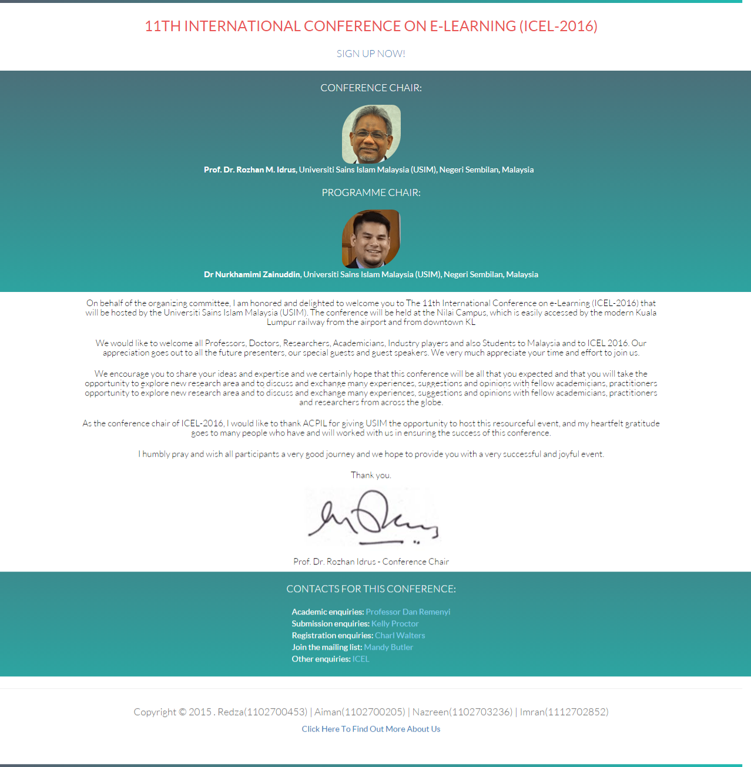

<!DOCTYPE html>
<html>
<head>
<title>TIS2151</title>
<link rel="icon" type="image/png" href="image/pagecon.png">
<meta charset=”utf-8”>
<meta name="viewport" content="width=device-width, initial-scale=1">
<link rel="stylesheet" href="css/bootstrap.css">
<link rel="stylesheet" href="css/style.css">
<link href="css/css" rel="stylesheet" type="text/css">
<link rel="stylesheet" href="css/animate.css">

</head>

<body>
<center>

<div class="parallax" style="padding: 0px 0 50px 0;">
<div class="topline"></div>

<div class="container"><a href="home2.html" style="text-decoration:none">
<h1 class="fade-in one">11th International Conference on e-Learning (ICEL-2016)</h1></a>
<h2 class="fade-in two"><a href="signup.html">SIGN UP NOW!</a></h2>
</div>

<!--CONTENT START HERE-->

<div class="row section1">
<table>
<tr>
<td><h2 class=div1>Conference Chair:</h2></td>
</tr>
<tr>
<td style="text-align: center"><img class="rcorners2" src="image/rozhan.png" alt="Rozhan"></td>
</tr>
<tr>
<td><strong>Prof. Dr. Rozhan M. Idrus</strong>, Universiti Sains Islam Malaysia (USIM), Negeri Sembilan, Malaysia</td>
</tr>
<tr>
<td><h2 class=div1>Programme Chair:</h2></td>
</tr>
<tr>
<td style="text-align: center"><img class="rcorners2" src="image/khami.png" alt="Nurkhamimi"></td>
</tr>
<tr>
<td><strong>Dr Nurkhamimi Zainuddin</strong>, Universiti Sains Islam Malaysia (USIM), Negeri Sembilan, Malaysia</td>
</tr>
</table>
<br>
</div>

<table width="80%">
<tr>
<td><h5 class="div1">
On behalf of the organizing committee, I am honored and delighted to welcome you to The 11th International Conference on e-Learning (ICEL-2016) that will be hosted by the Universiti Sains Islam Malaysia (USIM). The conference will be held at the Nilai Campus, which is easily accessed by the modern Kuala Lumpur railway from the airport and from downtown KL
</td>
</tr>
<tr>
<td><h5 class="div1">
We would like to welcome all Professors, Doctors, Researchers, Academicians, Industry players and also Students to Malaysia and to ICEL 2016. Our appreciation goes out to all the future presenters, our special guests and guest speakers. We very much appreciate your time and effort to join us.
</td>
</tr>
<tr>
<td><h5 class="div1">
We encourage you to share your ideas and expertise and we certainly hope that this conference will be all that you expected and that you will take the opportunity to explore new research area and to discuss and exchange many experiences, suggestions and opinions with fellow academicians, practitioners and researchers from across the globe.
</td>
</tr>
<tr>
<td><h5 class="div1">
As the conference chair of ICEL-2016, I would like to thank ACPIL for giving USIM the opportunity to host this resourceful event, and my heartfelt gratitude goes to many people who have and will worked with us in ensuring the success of this conference.
</td>
</tr>
<tr>
<td><h5 class="div1">
I humbly pray and wish all participants a very good journey and we hope to provide you with a very successful and joyful event.
</td>
</tr>
<tr>
<td><h5 class="div1">
Thank you.
</h5>
</td>
</tr>
<tr>
<td style="text-align: center">
<img class="rcorners3" src="image/signroz.png">
</td>
</tr>
<tr>
<td><h5 class="div1"> Prof. Dr. Rozhan Idrus - Conference Chair
</td>
</tr>
</table>

<div class="row section1">
<h2 class="div1">Contacts for this Conference:</h2>
<table>
<tr>
<td>Academic enquiries: <a style="color:skyblue" href="dan.remenyi@academic-publishing.org">Professor Dan Remenyi</a>
</tr>
<tr>
<td>Submission enquiries: <a style="color:skyblue" href="Kelly.proctor@academic-conferences.org">Kelly Proctor</a>
</tr>
<tr>
<td>Registration enquiries: <a style="color:skyblue" href="charl@academic-conferences.org">Charl Walters</a>
</tr>
<tr>
<td>Join the mailing list: <a style="color:skyblue" href="http://academic-conferences.org/join-mailing-list.htm">Mandy Butler</a>
</tr>
<tr>
<td>Other enquiries: <a style="color:skyblue" href="mandy@academic-conferences.org">ICEL</a>
</tr>
</table>
<br>

</div>

<!--CONTENT END HERE-->

<hr>
<table>
<tr><td style="text-align: center;"><h4>Copyright &copy; 2015 . Redza(1102700453) | Aiman(1102700205) | Nazreen(1102703236) | Imran(1112702852)</h4></td></tr>

<tr><td style="text-align: center;"><a href="aboutus2.html">Click Here To Find Out More About Us</a></td></tr>
</table>
</center>
<div class="topline"></div>
</body>
</html>

3. Sign Up Page
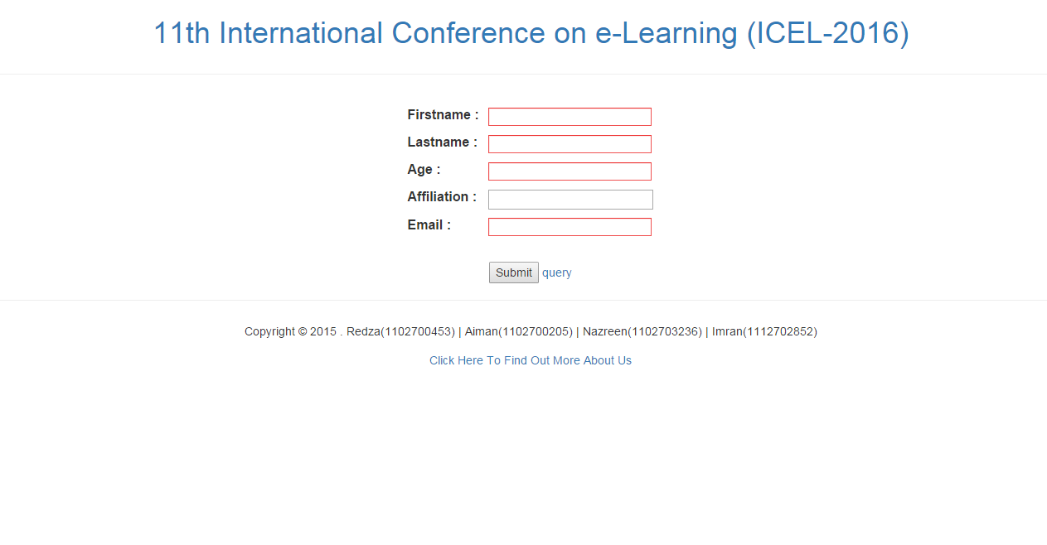

<html>
<head>
<title>TIS2151</title>
<link rel="icon" type="image/png" href="image/pagecon.png">
<meta charset=”utf-8”>
<meta name="viewport" content="width=device-width, initial-scale=1">
<link rel="stylesheet" href="css/bootstrap.css">
<link rel="stylesheet" href="css/page.css">
<link href="css/css" rel="stylesheet" type="text/css">
<link rel="stylesheet" href="css/animate.css">

</head>

<body>
<center>

<div class="parallax" style="padding: 0px 0 50px 0;">
<div class="topline"></div>

<div class="container"><a href="home2.html" style="text-decoration:none">
<h1 class="fade-in one">11th International Conference on e-Learning (ICEL-2016)</h1></a>
</div>

<!--CONTENT START HERE-->
<hr>
<form action="php/myfile2.php" method="post" >
<br>
<table>
<tr>
<td><p><label>Firstname :</label></td><td><span style = "margin-left : 5%"><input type="text" name="firstname" /></span></p></td>
</tr>
<tr>
<td><p><label>Lastname :</label></td><td><span style = "margin-left : 5%"><input type="text" name="lastname" /></span><p/></td>
</tr>
<tr>
<td><p><label>Age :</label></td><td><span style = "margin-left : 5%"><input type="text" name="age" /></span></p></td>
</tr>
<tr>
<td><p><label>Affiliation :</label></td><td><span style = "margin-left : 5%"><input type="text" name="affiliation" /></span></p></td>
</tr>
<tr>
<td><p><label>Email :</label></td><td><span style = "margin-left : 5%"><input type="email" name="email"/></span></p></td>
</tr>
</table>
<br>
<input type="submit" />
<a href="php/query.php"> query</a>

<div class="container-feedback">
</form>
</div>
<!--CONTENT END HERE-->

<hr>
<table>
<tr><td style="text-align: center;"><h5><span>Copyright &copy; 2015 . Redza(1102700453) | Aiman(1102700205) | Nazreen(1102703236) | Imran(1112702852)</span></h5></td></tr>
<tr><td style="text-align: center;"><a href="aboutus2.html"><h5>Click Here To Find Out More About Us</h5></a></td></tr>
</table>
</center>
</body>
</html>

4. About Us Page
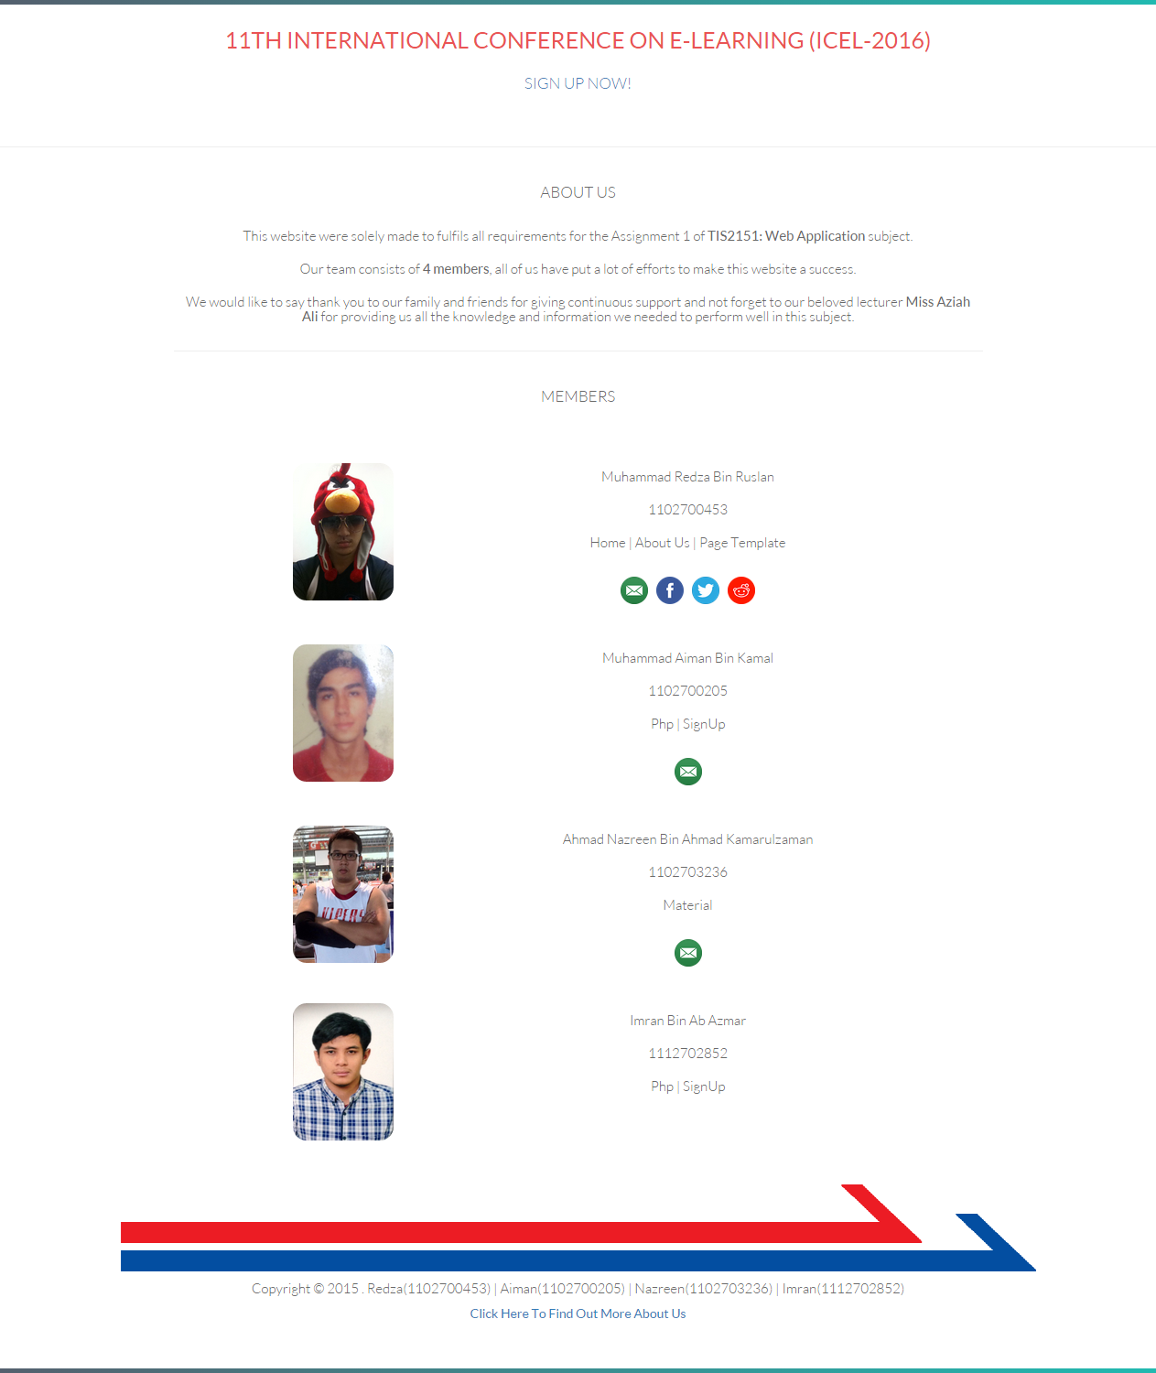

<!DOCTYPE html>
<html>
<head>
<title>About Us</title>
<meta charset="utf-8" />
<link rel="icon" type="image/png" href="image/pagecon.png">
<meta charset=”utf-8”>
<meta name="viewport" content="width=device-width, initial-scale=1">
<link rel="stylesheet" href="css/bootstrap.css">
<link rel="stylesheet" href="css/style.css">
<link href="css/css" rel="stylesheet" type="text/css">
<link rel="stylesheet" href="css/animate.css">

</head>

<body>
<center>
<div class="parallax" style="padding: 0px 0 50px 0;">
<div class="topline"></div>

<div class="container"><a href="home2.html" style="text-decoration:none">
<h1 class="fade-in one">11th International Conference on e-Learning (ICEL-2016)</h1></a>
<h2 class="fade-in two"><a href="signup.html">SIGN UP NOW!</a></h2>
<br>
</div>
<hr>
<!--CONTENT START HERE-->

<table width="70%">
<tr>
<th colspan="2" style="text-align: center;"><h2>About Us</h2></th>
</tr>
<tr>
<td colspan="2"><h6>This website were solely made to fulfils all requirements for the Assignment 1 of <span>TIS2151: Web Application</span> subject.</h6></td>
</tr>
<tr>
<td colspan="2"><h6>Our team consists of <span>4 members</span>, all of us have put a lot of efforts to make this website a success.</h6></td>
</tr>
<tr>
<td colspan="2"><h6>We would like to say thank you to our family and friends for giving continuous support and not forget to our beloved lecturer <span>Miss Aziah Ali</span>
for providing us all the knowledge and information we needed to perform well in this subject.</h6></td>
</tr>
<tr>
<th colspan="2" style="text-align: center;"><hr></th>
</tr>

<tr>
<th colspan="2" style="text-align: center;"><h2>MEMBERS</h2></th>
</tr>

<tr><td><br><br></td></tr>

<tr>
<td rowspan="5" style="text-align: right;"><img class="rcorners3" src="image/red.jpg" alt="Redza" width="110px" height="150px"></td>
<td style="text-align: center;"><h6>Muhammad Redza Bin Ruslan</h6></td>
</tr>
<tr>
<td style="text-align: center;"><h6>1102700453</h6></td>
</tr>
<tr>
<td style="text-align: center;"><h6>Home | About Us | Page Template</h6></td>
</tr>
<tr>
<td><br></td>
</tr>
<tr>
<td style="text-align: center;">
<a href="mailto:redzrex@gmail.com" target="_blank"><img src="image/email.png" alt="Send to my Email" width="30px" height="30px" hspace="3"></a>
<a href="https://www.facebook.com/redzrex" target="_blank"><img src="image/facebook.png" alt="Add Me at Facebook" width="30px" height="30px" hspace="3"></a>
<a href="https://twitter.com/redzrex" target="_blank"><img src="image/twitter.png" alt="Follow Me @redzrex" width="30px" height="30px" hspace="3"></a>
<a href="https://www.reddit.com/user/redzrex/" target="_blank"><img src="image/reddit.png" alt="Message me at Reddit" width="30px" height="30px" hspace="3"></a>
</td>
</tr>

<tr><td><br><br></td></tr>

<tr>
<td rowspan="5" style="text-align: right;"><img class="rcorners3" src="image/aiman.jpg" alt="Aiman" width="110px" height="150px"></td>
<td style="text-align: center;"><h6>Muhammad Aiman Bin Kamal</h6></td>
</tr>
<tr>
<td style="text-align: center;"><h6>1102700205</h6></td>
</tr>
<tr>
<td style="text-align: center;"><h6>Php | SignUp</h6></td>
</tr>
<tr>
<td><br></td>
</tr>
<tr>
<td style="text-align: center;">
<a href="mailto:aimankamal_92@yahoo.com" target="_blank"><img src="image/email.png" alt="Send to my Email" width="30px" height="30px" hspace="3"></a>
</td>
</tr>

<tr><td><br><br></td></tr>

<tr>
<td rowspan="5" style="text-align: right;"><img class="rcorners3" src="image/naz.jpg" alt="Nazreen" width="110px" height="150px"></td>
<td style="text-align: center;"><h6>Ahmad Nazreen Bin Ahmad Kamarulzaman</h6></td>
</tr>
<tr>
<td style="text-align: center;"><h6>1102703236</h6></td>
</tr>
<tr>
<td style="text-align: center;"><h6>Material</h6></td>
</tr>
<tr>
<td><br></td>
</tr>
<tr>
<td style="text-align: center;">
<a href="mailto:akira9212@gmail.com" target="_blank"><img src="image/email.png" alt="Send to my Email" width="30px" height="30px" hspace="3"></a>
</td>
</tr>

<tr><td><br><br></td></tr>

<tr>
<td rowspan="5" style="text-align: right;"><img class="rcorners3" src="image/imran.jpg" alt="Imran" width="110px" height="150px"></td>
<td style="text-align: center;"><h6>Imran Bin Ab Azmar</h6></td>
</tr>
<tr>
<td style="text-align: center;"><h6>1112702852</h6></td>
</tr>
<tr>
<td style="text-align: center;"><h6>Php | SignUp</h6></td>
</tr>
<tr>
<td><br></td>
</tr>
<tr>
<td><br></td>
</tr>

</table>

<!--CONTENT END HERE-->

<h3>&nbsp;</h3>
<table>
<tr><td style="text-align: center;"><img src="http://i.imgur.com/W01bvc0.png" alt="external link footer image"></td></tr>
<tr><td style="text-align: center;"><h6>Copyright &copy; 2015 . Redza(1102700453) | Aiman(1102700205) | Nazreen(1102703236) | Imran(1112702852)</h6></td></tr>
<tr><td style="text-align: center;"><a href="aboutus2.html">Click Here To Find Out More About Us</a></td></tr>
</table>
</center>
<div class="topline"></div>
</body>
</html>

